**Free Throw Game**

**Description:**

Free throw game is a simple game similar to shooting a free throw in Basketball. The character will be at the corner will shoot the ball to a basket object in the opposite side/wall.

This game will be generated in sprite kit and will adopt the animation for the ball bouncing around the screen. When the ball touches the edges, it will make a sound. Will try to add counter for the shot taken and successful shots.

**Pseudocode:**

* New project – Game in swift
* Add app icon and launch image
* Adding framework for UIKit and Core Animation for animations
* Using the Block-Based Methods to initiate animations and different levels of configuration for the ball animation.
* The ball will have force and direction, which can be determined by adding Animation Views and Motion Effects.
* Determining the position of ball with projectile equation. In the beginning, will use three fixed paths, but later can include simple equations.
* The character and basket will be in fixed position and force and direction will be changing.

Visual Design Template:

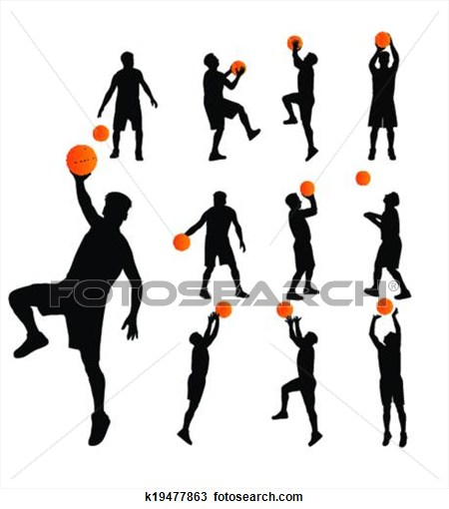

Score  
2/5

*Images taken from http://www.fotosearch.com/clip-art/basketball.html

**Testing the Project:**

* Proper Image sizes for app icon.
* Add launchImage.
* Test for proper connection of buttons in connection inspector
* While making new file with Cocoa Touch check the class.
* Check the subclass of view controller.
* Take snapshots after writing every code in controller and make connections.
* Stepwise development (building after every change) so that you know where the error is.
* Debugging by adding breakpoints
* Test the navigational consistency so that information for each condition is displayed correctly.
* Adding and updating of constraints according to the requirement of buttons.
* Check the deployment info and in deployment target always make it 8.0 and above
* Build app in xcode 6.1 and try running it in 6.0.1 to avoid crashes.